

TITLE Section 4

INCLUDE Irvine32.inc

.code

main PROC

mov eax, 47d ; EAX = 47

add eax, 39d ; EAX = 47 + 39

add eax, 60d ; EAX = 60+ 47 + 39

add eax, 85d

add eax, 64d

add eax, 54o

sub eax, 0Ah ; subtracting hexa value

call DumpRegs

exit

main ENDP

END main

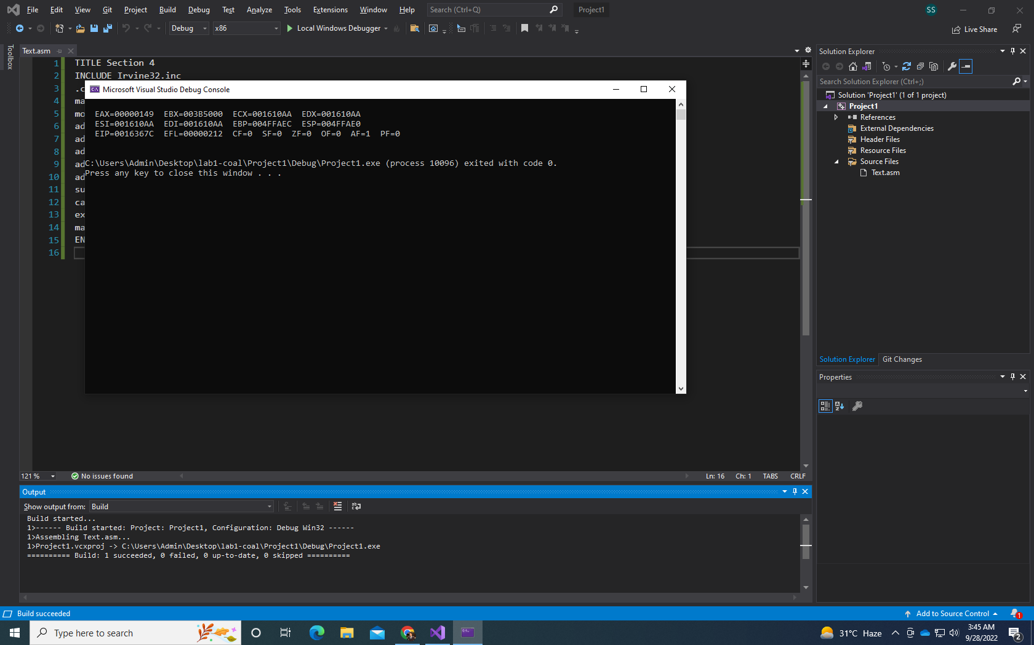



TITLE Add and Subtract

INCLUDE Irvine32.inc

.code

main PROC

mov eax, 30d

sub eax, 9d

add eax, 186d

sub eax, 150d

call DumpRegs

exit

main ENDP

END main

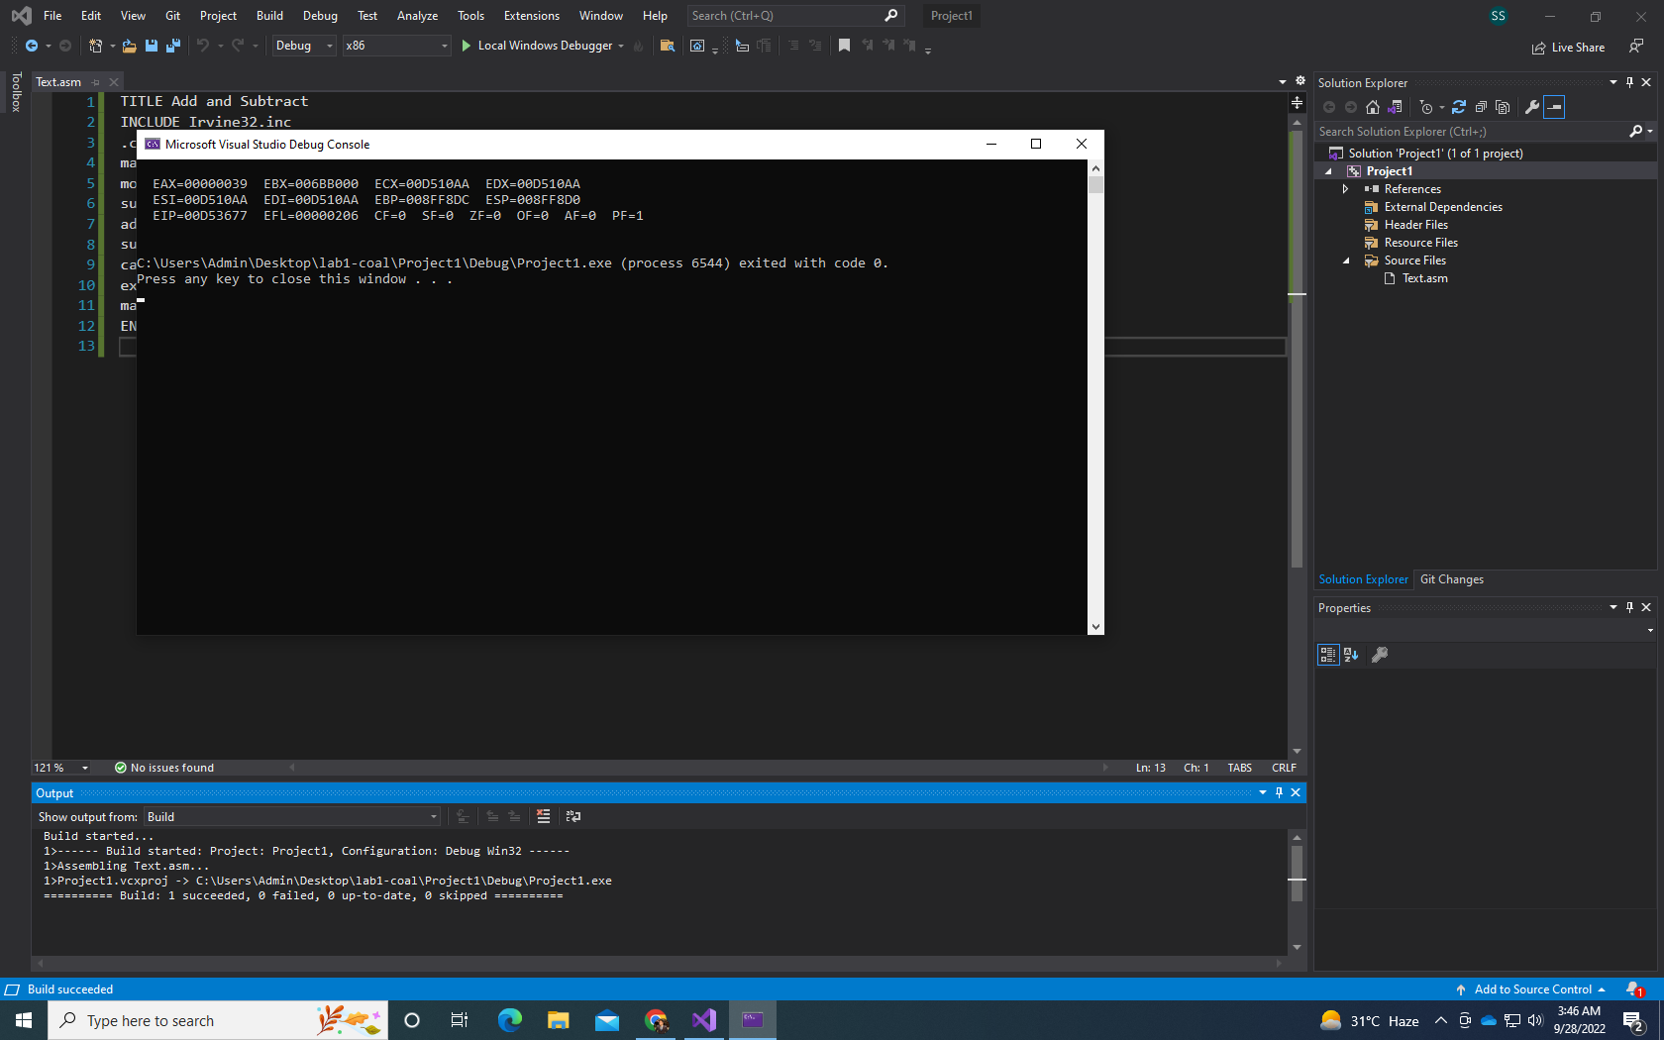



TITLE Section 4

INCLUDE Irvine32.inc

.code

main PROC

mov eax, 101110b

add eax, 50Ah

add eax, 6710d

add eax, 1010001b

add eax, 0Fh

call DumpRegs

exit

main ENDP

END main

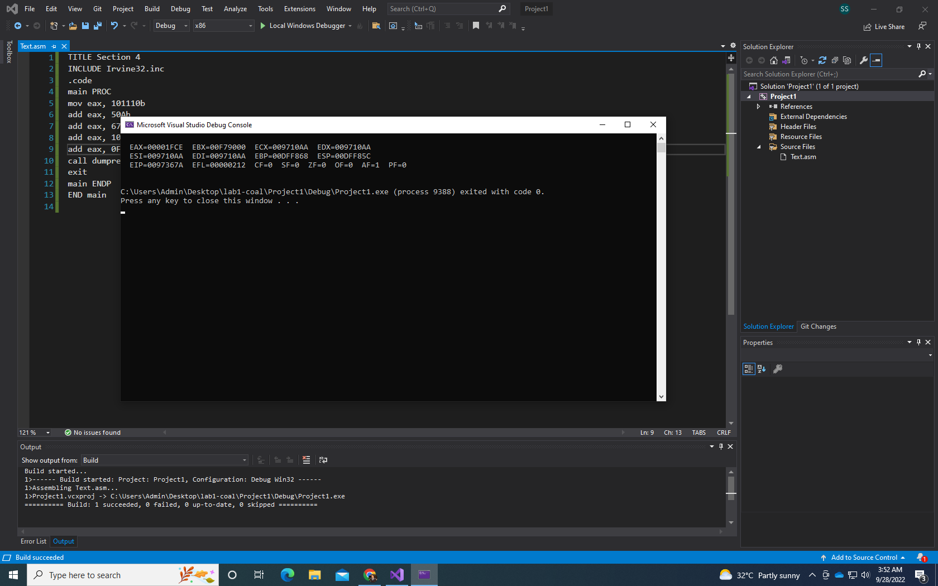



TITLE Add and Subtract

INCLUDE Irvine32.inc ; 10001101 – D83h + 385 + 10 + 1111101 – E + F

.code

main PROC

mov eax, 10001101b

sub eax, D83h

add eax, 385d

add eax, 10d

add eax, 1111101b

sub eax, Eh

add eax, fh

call DumpRegs

exit

main ENDP

END main

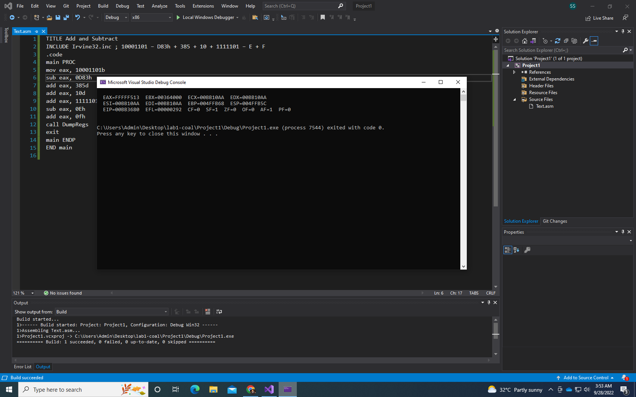



include Irvine32.inc

.code

main PROC

MOV ebx, 1

ADD ebx, 0AH

ADD ebx, 73d

SUB ebx, 65o

ADD ebx, edx

SUB ebx, ecx

SUB ebx, eax

MOV edx, ebx

call DumpRegs

exit

main ENDP

end main

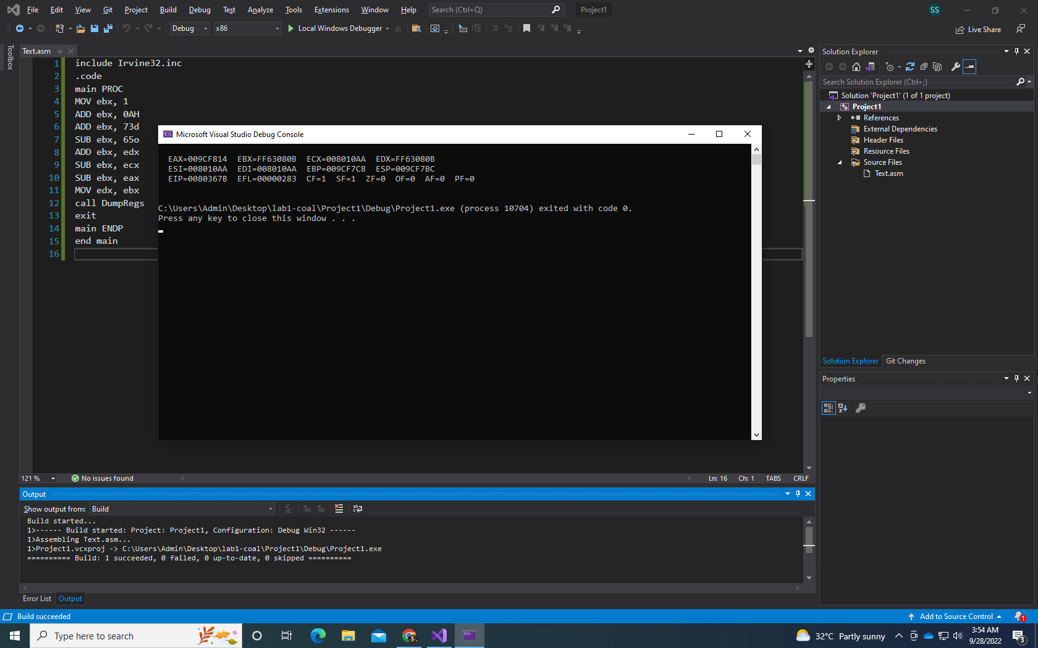



include irvine32.inc

.code

main proc

MOV edx, 5ADh

ADD edx, 65o

ADD edx, 65d

SUB edx, 11110111

ADD edx, 150d

SUB edx, eax

MOV eax, edx

call dumpregs

exit

main endp

end main

